|  |  |
| --- | --- |
| Fujifilm GF 45-100mm f/4 R LM OIS WR lens  Ống kính Fujifilm GF 45-100mm f/4 R LM OIS WR | Chính hãng  Fujifilm GF 45-100mm f4 R LM OIS WR 3 Fujifilm GF 45-100mm f4 R LM OIS WR 4 Fujifilm GF 45-100mm f4 R LM OIS WR 5 Fujifilm GF 45-100mm f4 R LM OIS WR 6 | **Featured information**  Linear AF motor, Internal focus  Optical image stabilization  Aperture range: f/4 to f/32  Weather-resistant design  Price : $ 2200  **Specifications:**  Focal distance  45 - 100mm  Largest Aperture  f/4  Smallest Aperture  f/32  Lens Mount  FUJIFILM G  Lens Format  Medium Format  View  62.6° - 30.6°  Minimum Focus Distance  65 cm  Magnification  0.13x  Optical Components  16 Elements in 12 Groups  Number of Mouth Blades  9  Focus Type  Autofocus  Anti-Vibration  Have |

**Overview:**

The Fujifilm GF 45-100mm f/4 R LM OIS WR lens is an essential zoom lens for Fujifilm GFX cameras. It is considered a highly versatile lens by providing a focal length range equivalent to 36-79mm on a 35mm format camera (the most frequently used focal range).

Whether capturing majestic landscapes, emotional portraits or creative still lifes, the Fujifilm GF 45-100mm f4 R LM OIS WR lens will make your subject truly shine.

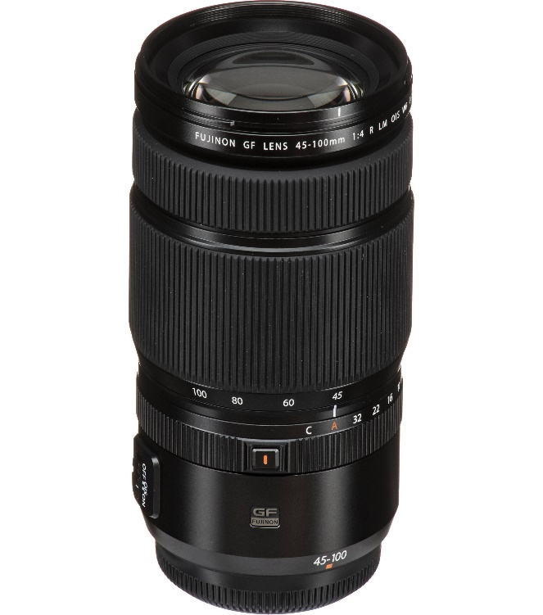

Fujifilm GF 45-100mm f/4 R LM OIS WR uses a special optical system to deliver high resolution and lifelike details. The f/4 maximum aperture delivers outstanding low-light performance, as well as stunning bokeh in any scene.

The lens has 16 elements in 12 groups, including three aspherical elements, one Super ED element, and one ED element. This optical structure is designed to control aberrations, curvature and distortion throughout the zoom range. All combined together help deliver amazingly sharp images.

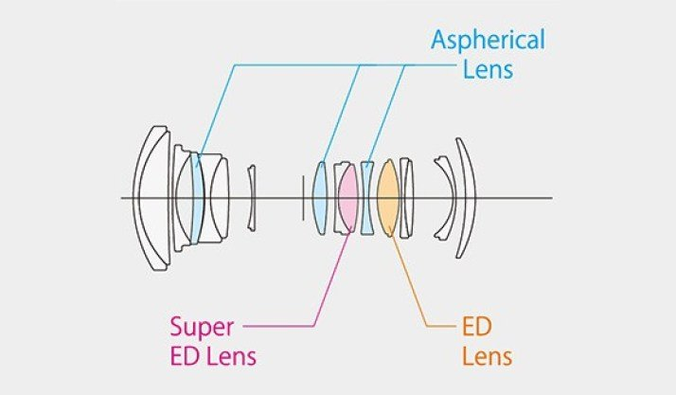

Powerful 5-axis optical image stabilization (OIS) in the Fujifilm GF 45-100mm f/4 lens helps keep images as sharp as possible, even when using slow shutter speeds and shooting handheld hand. A convenient switch on the lens body allows you to turn this feature off when used with a tripod or other fixed point.

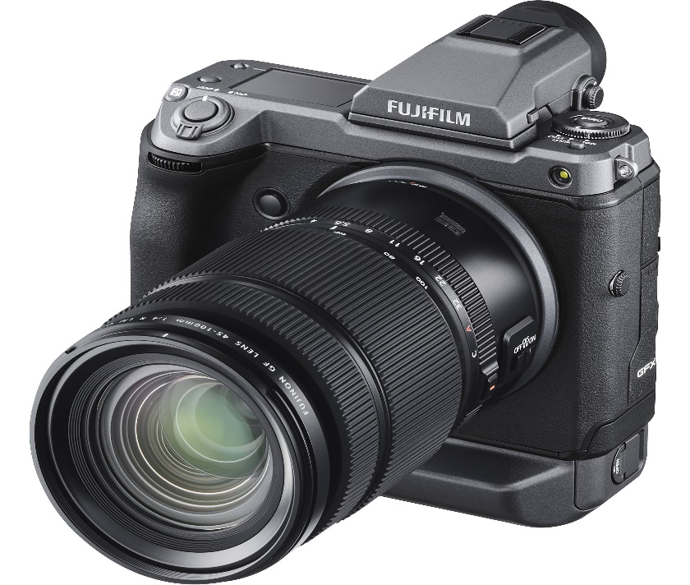

Confidently shoot in any situation without fear of missing out or affecting the surrounding space. With a linear AF motor, the Fujifilm GF 45-100mm f/4 R LM OIS WR lens is capable of fast, accurate, and nearly silent autofocus. The lens' internal focusing system also contributes to its lighter weight design, enhancing its operability.